 TEAM ID : PNT2022TMID40963



**SOLUTION ARCHITECTURE**

**Project NAME:IOT BASED SMART CROP**

**PROTECTION SYSTEM FOR AGRICULTURE**





**camera Module**

**IOT BASED SMART CROP**

**PROTECTION SYSTEM FOR AGRICULTURE**

Temperature sensor

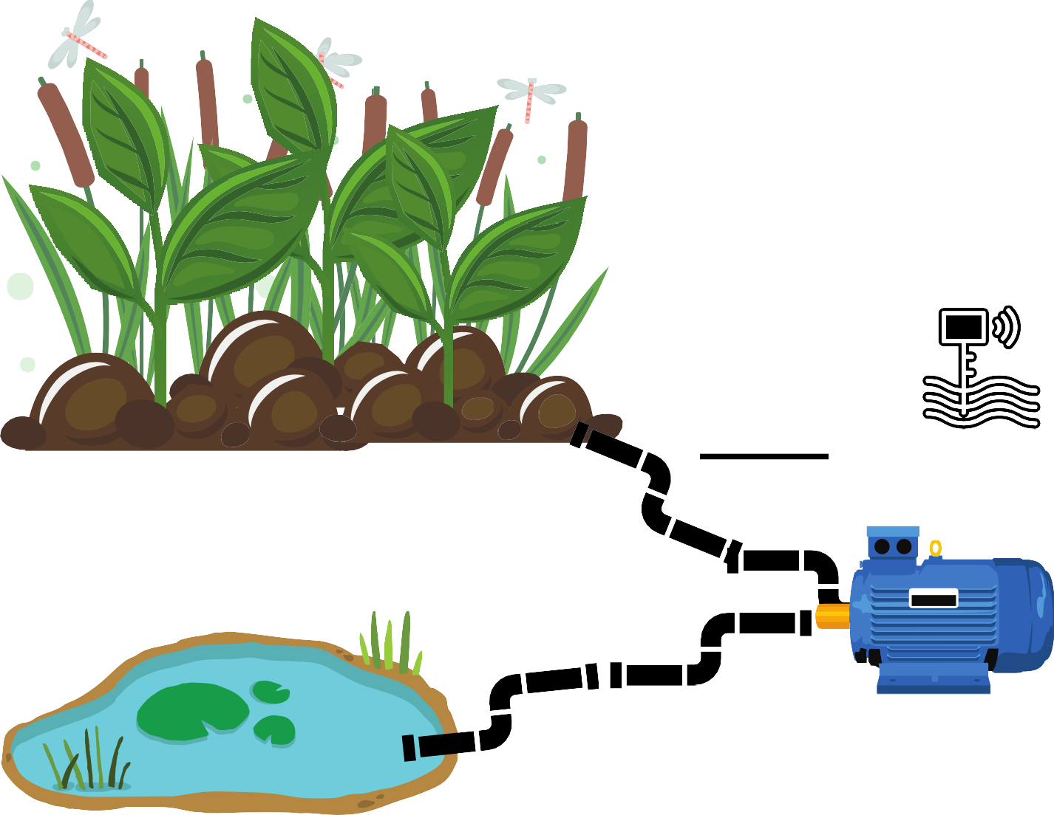

Flame sensor

PH sensorCELLULAR NETWORK

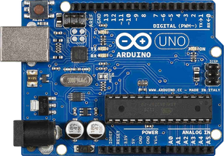

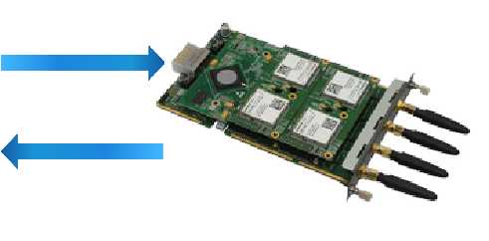**ARDUINO MICRO GATEWAY MODULE ROUTER INTERNECLOUD**

**CONTROLLLL**

water AND Moisture level sensor



**NOW I CAN MONITOR FARM AT ANYTIME AND**

**ANYWHERE**

**Motor Pump**